# Tests

Contents

Tests 1

Scenario 1 1

test1_1MoveLeftPushedBackHorizontally01 1

test1_2MoveLeftPushedBackDownRight02 1

test1_3MoveInsertedVertically1 1

test1_4MovePushedVertically2 1

Scenario 2 2

Test2_1InsertAndPushedRightHorizontally 2

test2_2PushedRightAndDownNicely 2

Scenario 3 2

test3_1PushedBetweenLeftAndRight 2

test3_2PushedBetweenLeftAndRightRefused 2

test3_2aPushedRefusedButLeftMovedAnyway 3

test3_3InsertedAndTwoPushedRight 3

test3_4InsertedVerticallyNothingPushedRight 3

test3_5InsertedVerticallyTwoPushedDown 3

Scenario 3a 3

test3a_1PushedLeft 3

test3a_2PushedLeftD97DoesntMove 4

test3a_3PushedLeftNotFlyingUpY 4

Scenario 4 5

test4_1InsertedTwoPushedRightTwoPushedDown 5

test4_2InsertedTwoPushedRightThreePushedDown 5

Scenario 5 – stress tests 6

Scenario 6 – line crossing enhancements 6

test6_1LineCrossingNotNeeded 6

test6_2LineCrossingAvoided 6

Scenario 7 – weird behaviour when edges involved 7

test7_1DontJumpTooFarY 7

test7_2DontJumpTooFarY 7

## Scenario 1

Basic tests. Note that the algorithm is tuned to move the minimum needed, so if moving Y is less distance than moving X then a vertical movement will be applied.

{'type':'node', 'id':'D25', 'x':6, 'y':7, 'width':159, 'height':106}

{'type':'node', 'id':'D13', 'x':6, 'y':119, 'width':119, 'height':73}

{'type':'node', 'id':'m1', 'x':170, 'y':9, 'width':139, 'height':92}

### test1_1MoveLeftPushedBackHorizontally01

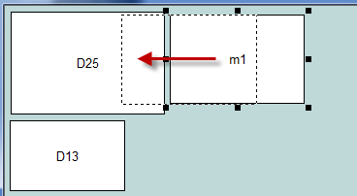 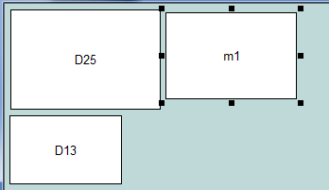

### test1_2MoveLeftPushedBackDownRight02

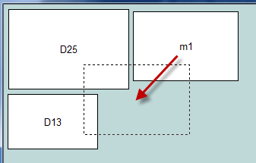 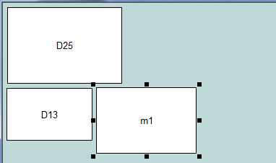

### test1_3MoveInsertedVertically1

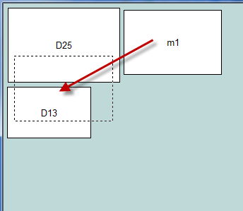 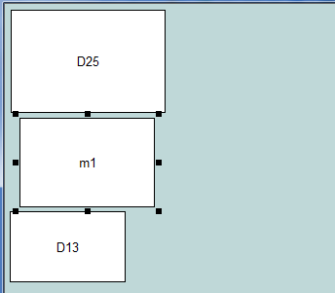

### test1_4MovePushedVertically2

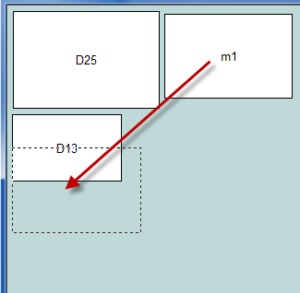 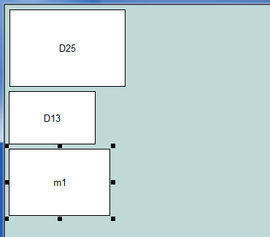

## Scenario 2

{'type':'node', 'id':'D25', 'x':7, 'y':6, 'width':159, 'height':106}

{'type':'node', 'id':'D13', 'x':6, 'y':119, 'width':119, 'height':73}

{'type':'node', 'id':'m1', 'x':146, 'y':179, 'width':139, 'height':92}

{'type':'node', 'id':'D97', 'x':213, 'y':6, 'width':85, 'height':159}

### Test2_1InsertAndPushedRightHorizontally

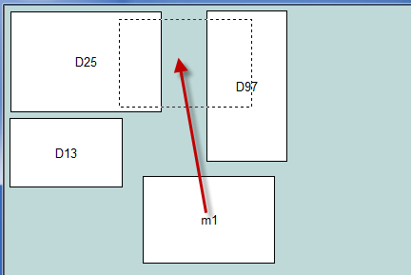 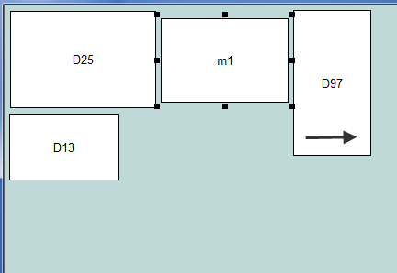

### test2_2PushedRightAndDownNicely

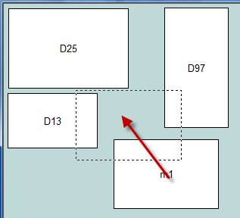 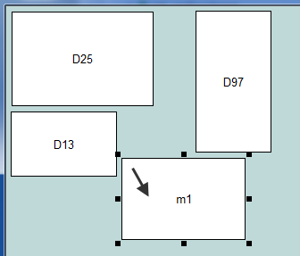

## Scenario 3

{'type':'node', 'id':'D25', 'x':7, 'y':6, 'width':159, 'height':106}

{'type':'node', 'id':'D13', 'x':6, 'y':119, 'width':119, 'height':73}

{'type':'node', 'id':'m1', 'x':246, 'y':179, 'width':139, 'height':92}

{'type':'node', 'id':'D97', 'x':213, 'y':6, 'width':85, 'height':159}

{'type':'node', 'id':'D98', 'x':340, 'y':7, 'width':101, 'height':107}

### test3_1PushedBetweenLeftAndRight

assert m1 has been pushed between two nodes, horizontally. Both left and right nodes moved left and right respectively.

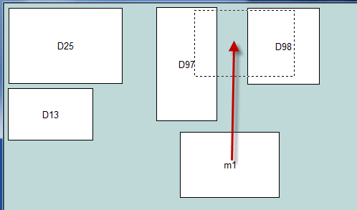 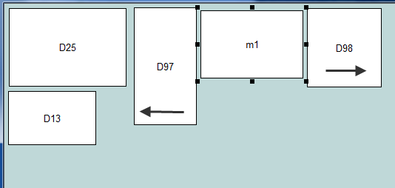

Or if snug logic is on, then 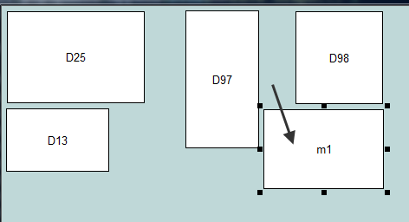 or 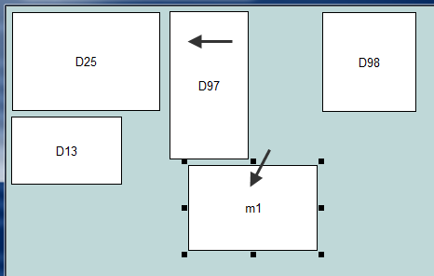

### test3_2PushedBetweenLeftAndRightRefused

assert m1 has been not been inserted - refused and snuggled instead

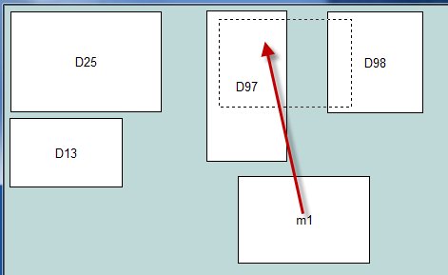 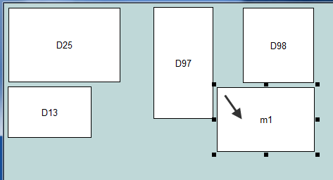

### test3_2aPushedRefusedButLeftMovedAnyway

m1 has been refused insertion, but left (D97) moved leftwards cos there is room. m1 snuggled below and to the right.

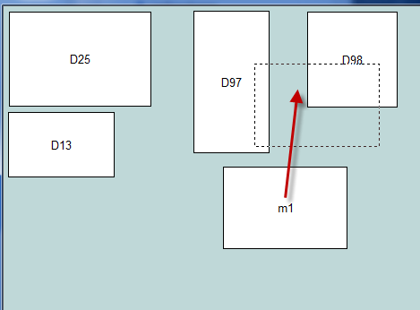 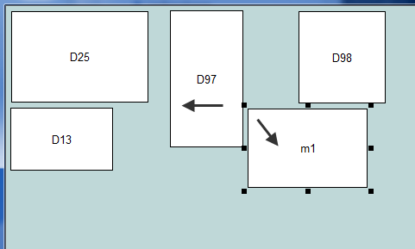

### test3_3InsertedAndTwoPushedRight

assert m1 has been inserted - and two nodes pushed right

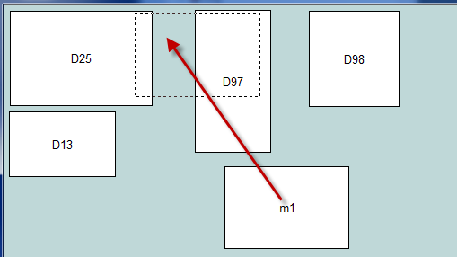 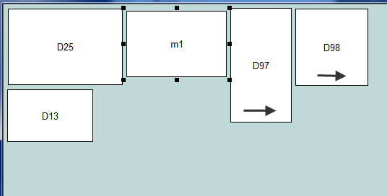

### test3_4InsertedVerticallyNothingPushedRight

assert m1 has been inserted vertically - one node pushed down, NO nodes pushed right

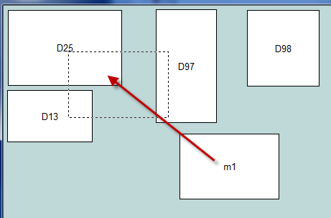 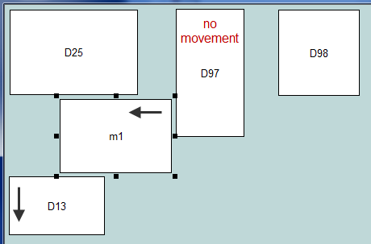

### test3_5InsertedVerticallyTwoPushedDown

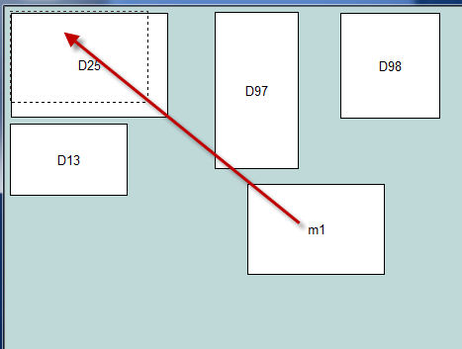 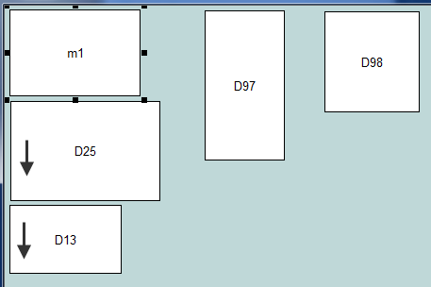

## Scenario 3a

{'type':'node', 'id':'D25', 'x':7, 'y':6, 'width':159, 'height':106}

{'type':'node', 'id':'D13', 'x':6, 'y':116, 'width':119, 'height':73}

{'type':'node', 'id':'m1', 'x':201, 'y':174, 'width':139, 'height':92}

{'type':'node', 'id':'D97', 'x':358, 'y':6, 'width':85, 'height':159}

{'type':'node', 'id':'D98', 'x':350, 'y':172, 'width':101, 'height':107}

### test3A_1PushedLeft

move m1 to the right, should be pushed back to the left

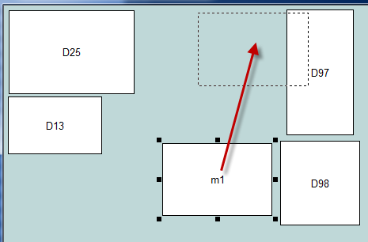 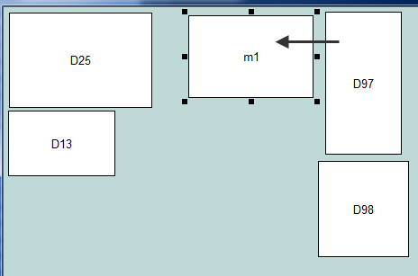

**not** 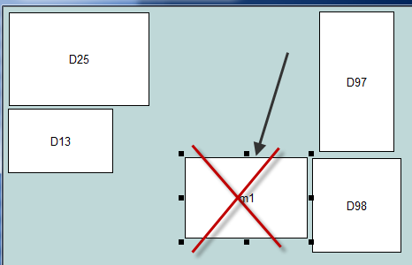

### test3A_2PushedLeftD97DoesntMove

# move m1 to the right, should be pushed back to the left. D97 shouldn't move!

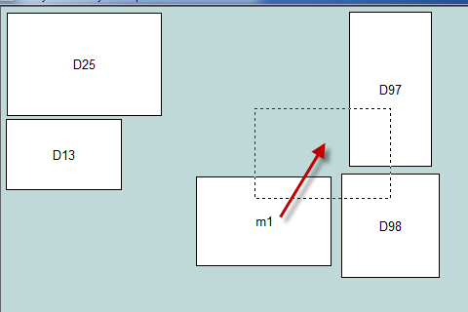 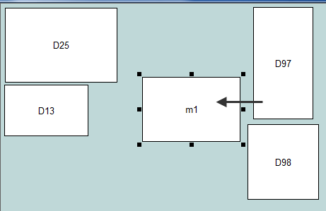

**not** 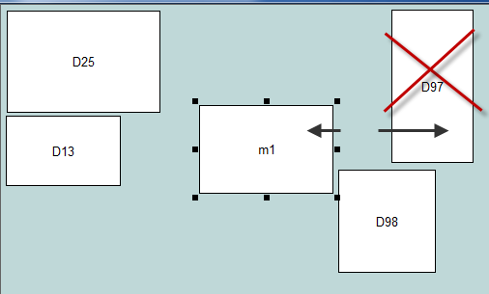

### test3A_3PushedLeftNotFlyingUpY

move m1 to the right, should be pushed back to the left. Not flown up Y. **Note that the top of m1 is > top of D98 to trigger this test**.

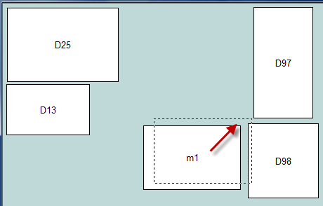 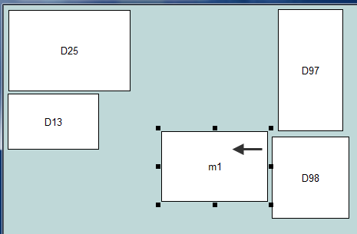

**not** 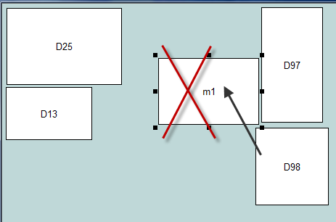

## Scenario 4

{'type':'node', 'id':'D25', 'x':7, 'y':6, 'width':159, 'height':106}

{'type':'node', 'id':'D13', 'x':6, 'y':119, 'width':119, 'height':73}

{'type':'node', 'id':'m1', 'x':6, 'y':214, 'width':139, 'height':92}

{'type':'node', 'id':'D97', 'x':213, 'y':6, 'width':85, 'height':159}

{'type':'node', 'id':'D98', 'x':305, 'y':57, 'width':101, 'height':107}

{'type':'node', 'id':'D50', 'x':149, 'y':184, 'width':242, 'height':112}

{'type':'node', 'id':'D51', 'x':189, 'y':302, 'width':162, 'height':66}

### test4_1InsertedTwoPushedRightTwoPushedDown

assert m1 has been inserted - two pushed right, two pushed down

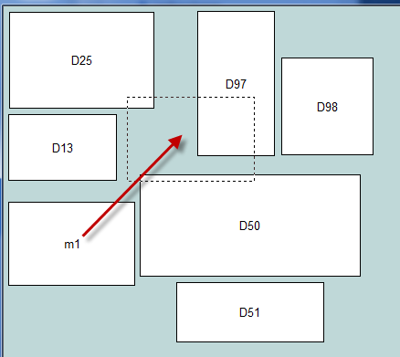 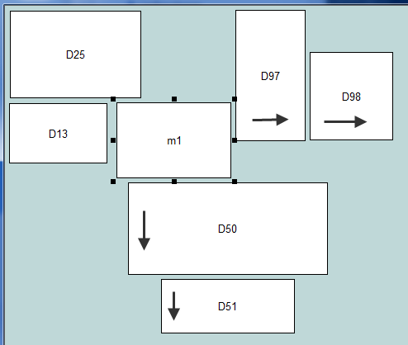

### test4_2InsertedTwoNotPushedRightThreePushedDown

assert m1 has been inserted - ~~two pushed right~~, two pushed down, and extra D13 pushed down because m1 overlaps/attacks D13 (and there is room for D13 to move downwards I guess)

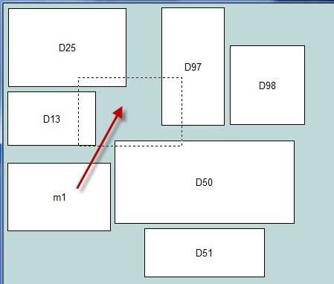 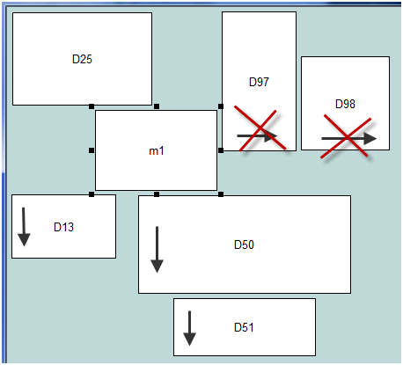

## Scenario 5 – stress tests

Run a complex jumble repeatedly till it fails. I increased MAX_CYCLES to 20 to improve success.

## Scenario 6 – line crossing enhancements

### test6_1LineCrossingNotNeeded

Usual repulsion and snuggling.

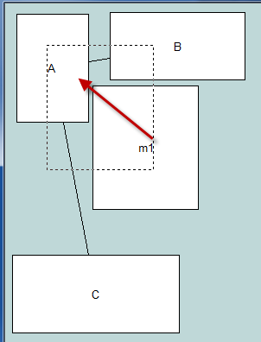 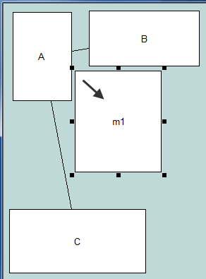

### test6_2LineCrossingAvoided

assert m1 has been repulsed and snuggeled, and line not crossed - same results as ABOVE

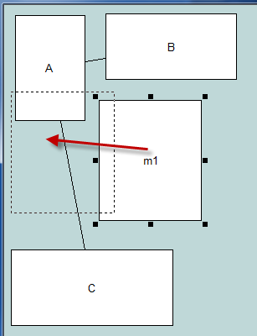  **or** 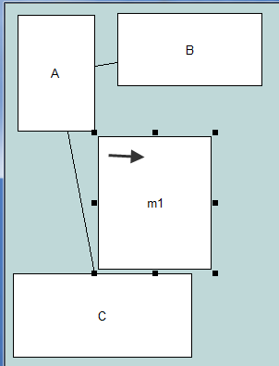

**not** 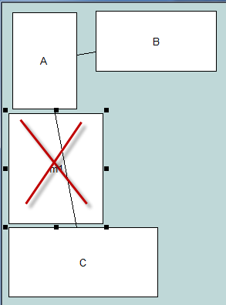

### test6_3LineCrossingAvoidedGoSnug

assert m1 has been repulsed up and to the right, snuggled, and line not crossed

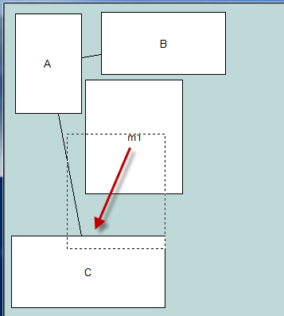 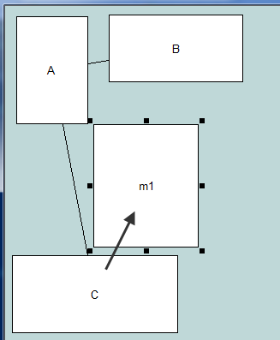 **not** 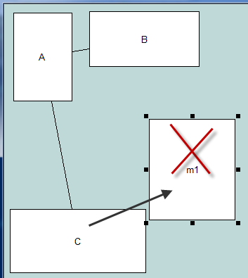

## Scenario 7 – weird behaviour when edges involved

### test7_1DontJumpTooFarY

assert m1 has been pushed to the right. don't see why edges should make any difference. initially found m1 was being pushed way too far down in the Y direction!

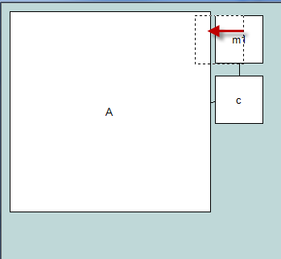 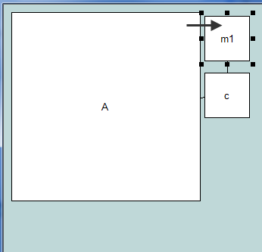 **not** 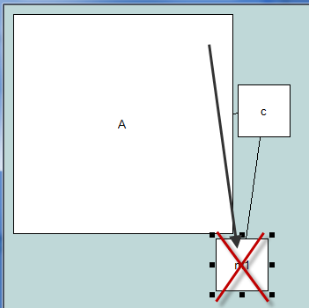

### test7_2DontJumpTooFarY

assert m1 has been pushed to the right and down – snugly – not pushed way too far down in the Y direction!

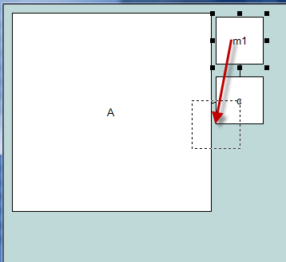 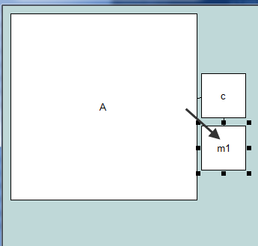 **not** 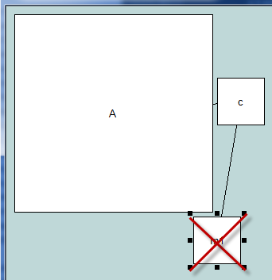

## Scenario 8 – Back to normal node overlapping

{'type':'node', 'id':'B1', 'x':17, 'y':17, 'width':56, 'height':106}

{'type':'node', 'id':'B2', 'x':164, 'y':9, 'width':52, 'height':112}

{'type':'node', 'id':'A', 'x':17, 'y':127, 'width':206, 'height':136}

{'type':'node', 'id':'m1', 'x':84, 'y':40, 'width':62, 'height':60}

### test8_1JumpUpAndSnuggle

assert m1 has been pushed up and to the right. Ok for B1 to be pushed a little left

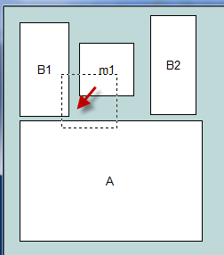 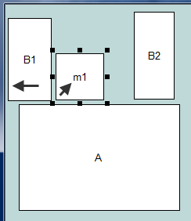

### test8_1JumpUpAndSnuggleB1PushedOk

assert m1 has been pushed up and to the right. We used to have it so moving y up was not an option for m1 so A got pushed down instead.

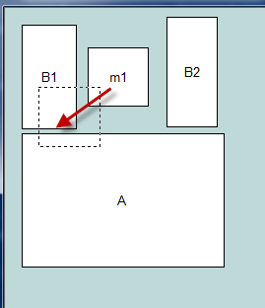 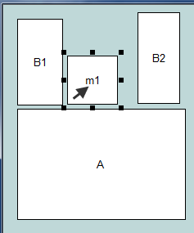 **not** 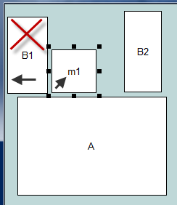

### test8_2JumpUpAndSnuggle

assert m1 has been pushed up and to the left. We used to have it so moving y up was not an option for m1 so A got pushed down instead.

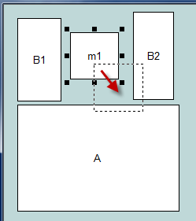 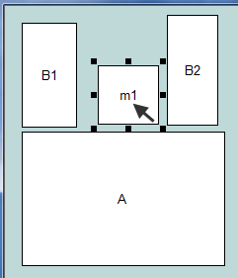 **not** 